申请城市环境所&宁诺联培博士项目（2022.9月入学）流程
一、导师团队确定
1、第一步须确定城市环境所导师接收，并与所方导师商定并联系宁波诺丁汉大学的校
方导师，校所导师建立招生的合作课题。城市环境所的博士生导师都有招生资格，具体招生导师可以浏览http://www.iue.cas.cn/iueyjsjy/jyzs/dsjs/201908/t20190808_5356418.html中所列的博士生导师。
二、个人报名
- 宁诺目前已启用新的线上申请系统 （更多信息，可详见https://www.nottingham.edu.cn/en/graduateschool/how-to-apply/how-to-apply.aspx）
- 进入上述链接后，可以看到入学条件、线上申请、常见问答等，如下图
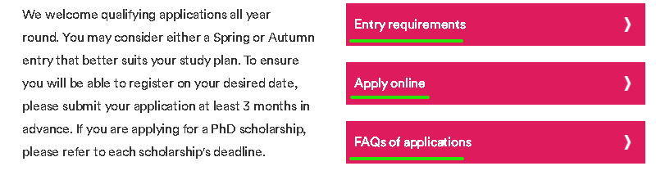

- Entry requirements:（网页中都有详细的描述请仔细查看，或查看材料所招生简章）
The following will be considered when making an offer:
Academic performance during the undergraduate and postgraduate study
Research papers published in international academic journals
Quality of the research proposal
Research potential and attitude
English proficiency
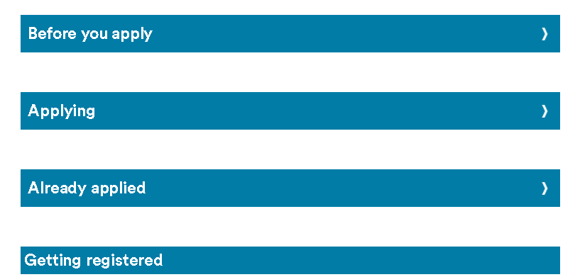

- Apply online：（2022年启用线上申请，取代原PGR application form）
先进行账号注册，并登陆
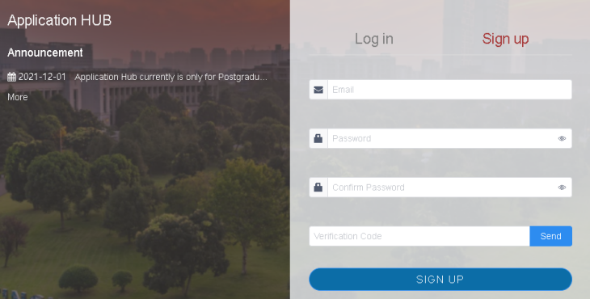

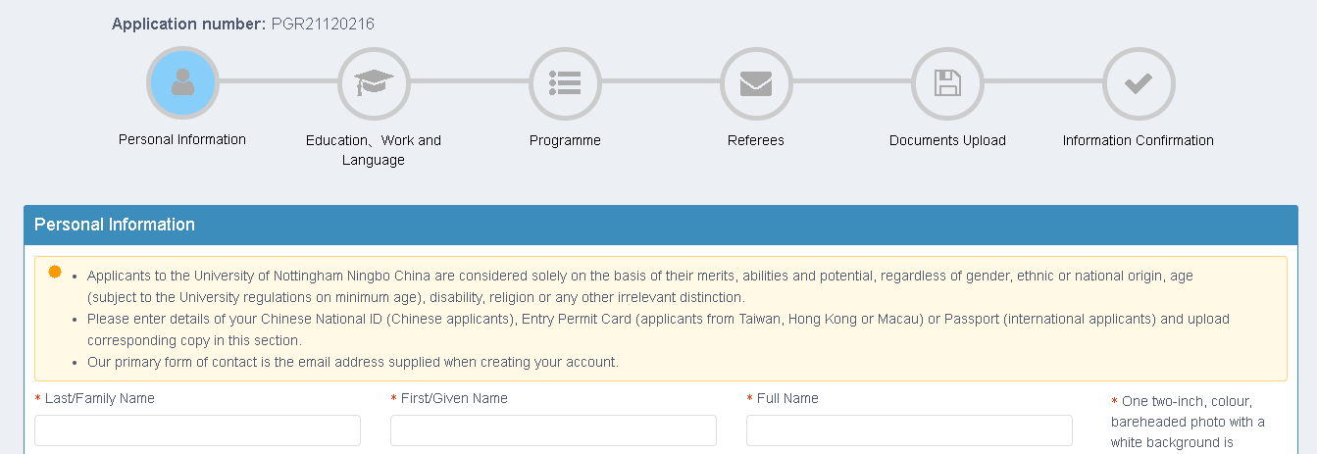
依次填写好个人信息，并提交

三、导师提交联合培养项目的奖学金申请表格
在个人申请审核通过后，进入双方导师审核阶段，并需要导师提交支持材料：
其中表 Approved PGR admission confirmation form 是由宁诺导师在宁诺系统填写，填写后将另外两个表PGR Applicant Assessment form、DTP Research Proposal Form 附在系统里一并提交，所以在收到材料初审通过后，尽快完成后续的 3 个表格。
注：附件2个表格，但可能会有变更，请去宁诺官网下载最新的表格
四、评审会召开
在完成以上导师提交支持材料后，校所双方将确定评审会时间，确定拟录取名单。
经审核完成，发放录取 offer 。
注：必须按要求在各个时间节点之前提交相应材料，申请才有效并进入下一阶段
以上为大致流程，若以上流程与宁诺最新规定有所出入，以宁诺最新规定为准。

五、材料清单
所有的材料都需要是英文的，或者中翻英的翻译件。下面是需要的材料：
- Apply online
- A research proposal
- Degree certificates for undergraduate and postgraduate studies with English translation.
▪ Graduation diplomas are also required for applicants graduating from Chinese universities.
▪ English translation has to be verified by the attended universities with their official stamps (on university headed paper, preferably).
▪ The “online Verification Report of Higher Education Qualification Certificate” in English obtained from China Higher Education Student Information (CHSI中国高等教育学生信息网) can be provided as an alternative of the English translation if a degree was gained from a Chinese university.
▪ Chinese applicants who obtained a degree abroad or in Taiwan, Hong Kong or Macao, please also provide the certification obtained from the Chinese Service Centre for Scholarly Exchange (教育部留学服务中心).
- Official transcripts with marks for all individual modules/courses from undergraduate and postgraduate studies and their English translation. A provisional transcript can be provided if you are still taking some modules but a final transcript has to be submitted when it is available. (Only official transcripts with university stamp can be accepted.)
- English Language test score report (IELTS/PTE academic etc.) if applicable (not required for native English speakers).
- A copy of passport (international applicants) or ID card (Chinese nationals, both sides of Chinese ID cards required).
- An electronic copy of passport-sized photo taken within three months of this application.
- A brief CV.
- Any supporting documents to demonstrate the research potential, if applicable, e.g. published papers, conference papers, patents, etc.
An application missing any of the above required documents (except for English language score) is regarded incomplete and will not be considered.
Documents submitted in any language other than English (except from prospects with a Chinese national ID or certification provided by the Chinese Service Centre for Scholarly Exchange) must be accompanied by an English translation.
You should be prepared to provide original documents or original certified copies of supporting documents at registration and upon request at any time. Failure to do so may result in your candidacy being rejected.
Please quote the scholarship reference number in your application form if you are applying for any UNNC scholarship.
If you have any questions about these requirements, please refer to frequently asked questions. If you cannot find what you are looking for, please email PGR@nottingham.edu.cn.

